Music Ensembles Management System (MEMS) - Comprehensive Technical Report

Executive Summary

Document Version: 1.0
Date: November 2025
Total Pages: 48
Project Team: MEMS Development Team
Table of Contents
1. Introduction & System Overview
1.1 Project Background .................................................................... 3
1.2 Business Context & Assumptions .......................................... 4
1.3 Technical Specifications ............................................................ 5
1.4 System Capabilities .................................................................... 6
2. Architectural Design
2.1 System Architecture .................................................................. 7
2.2 Core Components Design ....................................................... 8
2.3 Class Relationships .................................................................... 27
2.4 Design Principles ....................................................................... 28
3. Design Patterns Implementation
3.1 Command Pattern .................................................................... 29
3.2 Memento Pattern ..................................................................... 31
3.3 Factory Pattern ......................................................................... 33
3.4 Strategy Pattern ....................................................................... 35
3.5 Design Pattern Integration ................................................... 37
4. Test Plan and Test Cases
4.1 Test Plan .................................................................................... 38
4.2 Test Cases ................................................................................. 39
4.3 Test Procedures ...................................................................... 44
5. Technical Documentation
5.1 Core Implementation ............................................................ 46
5.2 Business Logic Layer .............................................................. 51
5.3 System Features Summary ................................................... 53
Appendices
Appendices ...................................................................................... 55

1. Introduction & System Overview

  - Project Background

Music Ensembles Management System (MEMS) represents a sophisticated software solution designed specifically for managing musical ensembles and their members. The system provides comprehensive tools for orchestra and band management, supporting both classical and jazz music organizations.

  - Business Context & Assumptions
Core Business Rules
Category | Specification
Ensemble Types | Orchestra and Jazz Band only
Musician Roles | Type-specific instrument configurations
Identification | Unique IDs for all entities
Workflow | Current ensemble selection model
Supported Instrument Configurations:
- Orchestra Ensembles
  - Violinists
  - Cellists
- Jazz Bands
  - Pianists
  - Saxophonists
  - Drummers

  - Technical Specifications

Development Environment

Platform: Java 8+
Interface: Console-based application
Storage: In-memory data persistence
Features: Complete undo/redo capability

Technical Constraints
- User Interface: Text-based console interaction
- Data Management: Runtime memory storage
- Error Handling: Comprehensive input validation
- Operation History: Limited command history tracking

  - System Capabilities

Core Functionality
- ✅ Ensemble creation and configuration
- ✅ Musician management operations
- ✅ Ensemble information display
- ✅ Operation history management
- ✅ Current ensemble context management

2. Architectural Design

2.1 System Architecture

2.1.1 Layered Architecture Design
MEMS employs a structured three-layer architecture ensuring clear separation of concerns and maintainable codebase.

Presentation Layer (View) → Controller Layer → Model Layer
User Interface Command Pattern Business Objects
Menu Display State Management Data Persistence

2.1.2 Design Principles Implementation

Applied Software Engineering Principles:
- Single Responsibility: Each class focused on specific functionality
- Open/Closed: Extensible through interfaces and abstraction
- Dependency Inversion: Decoupled high-level and low-level modules
- Interface Segregation: Client-specific interface design

2.2 Core Components Design

2.2.1 MEMS Main System Class
Primary Responsibilities:
- System initialization and component management
- User interaction handling and menu presentation
- Command dispatching and execution coordination
- State maintenance and history management

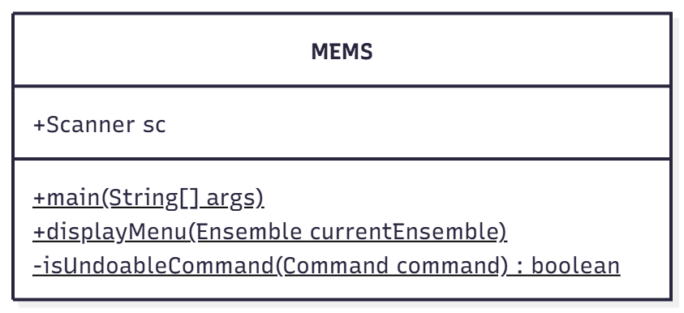
Figure 2.3: MEMS Main Class Structure
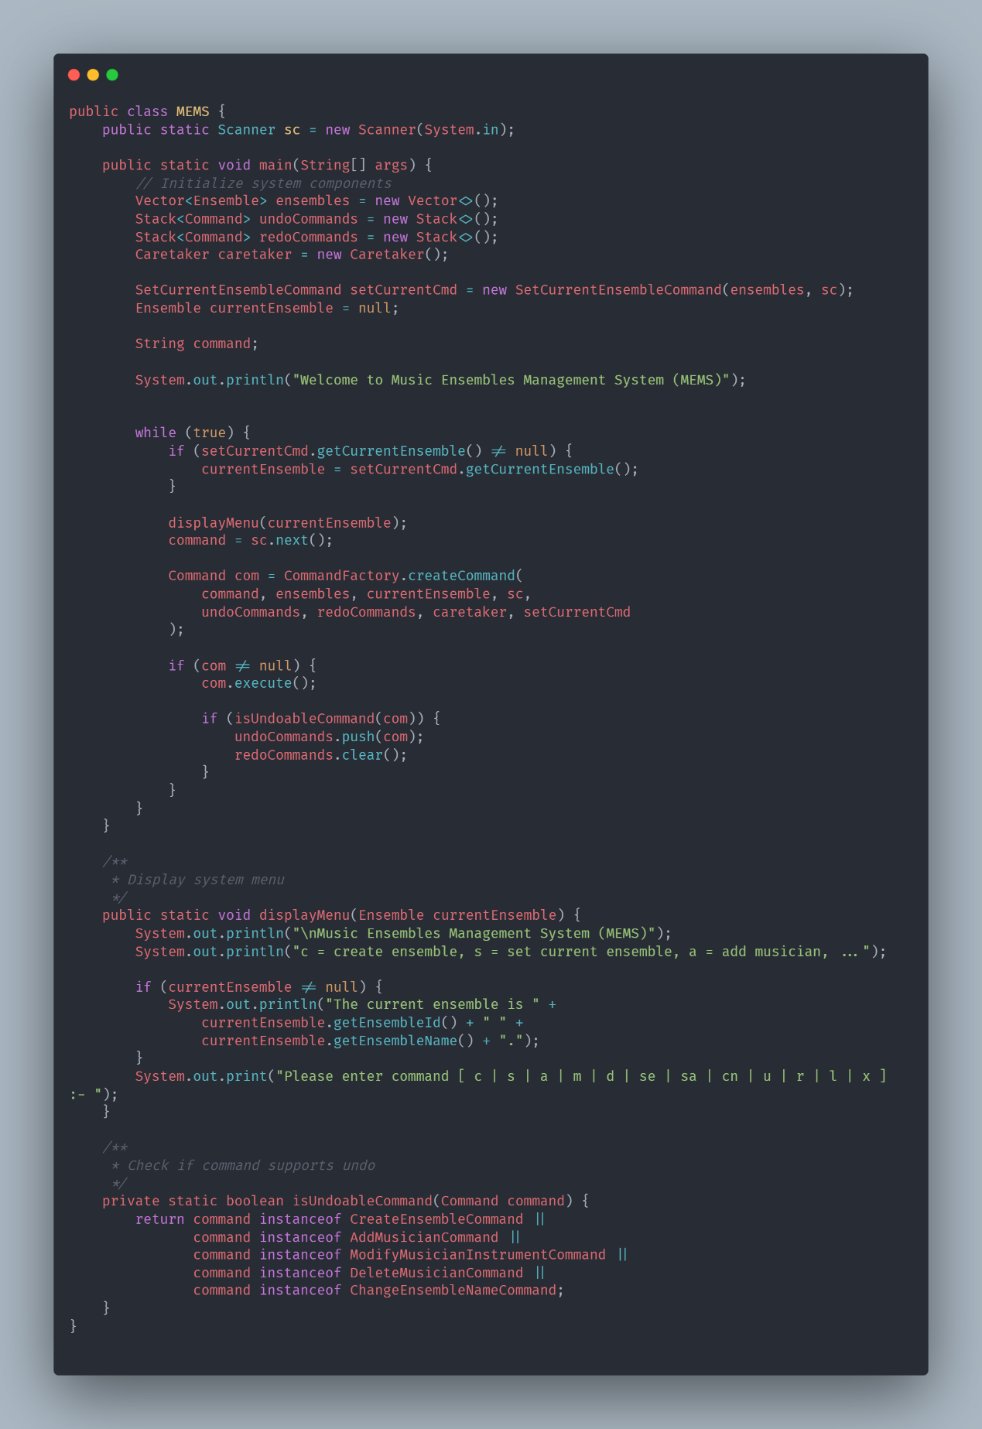
Figure 2.4: MEMS Main Class Implementation

2.2.2 Command Interface

Interface Contract:
- Unified command execution interface
- Operation encapsulation as objects
- Undo/redo capability foundation
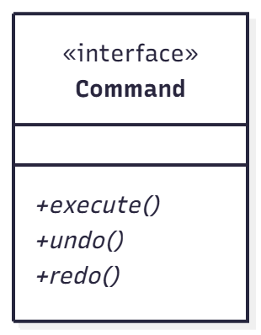
Figure 2.5: Command Interface Design

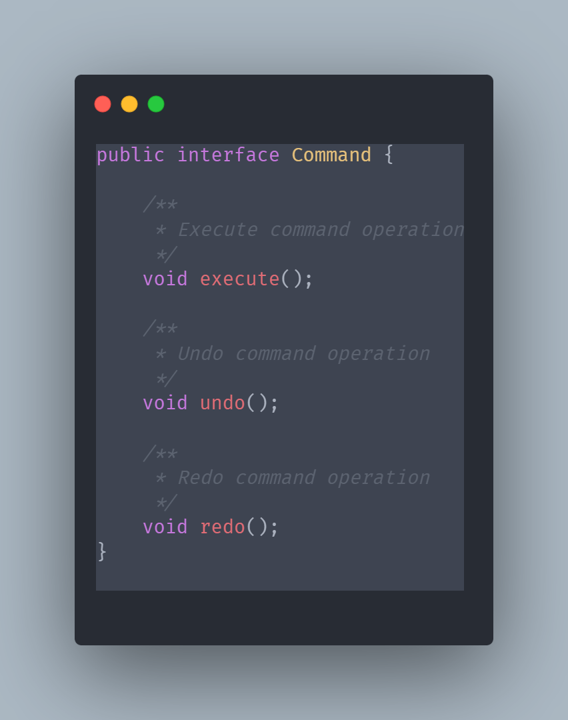
Figure 2.6: Command Interface Implementation

2.2.3 Command Factory Implementation

Factory Responsibilities:
- Command object instantiation based on user input
- Dependency injection for command objects
- Runtime type resolution and operation availability

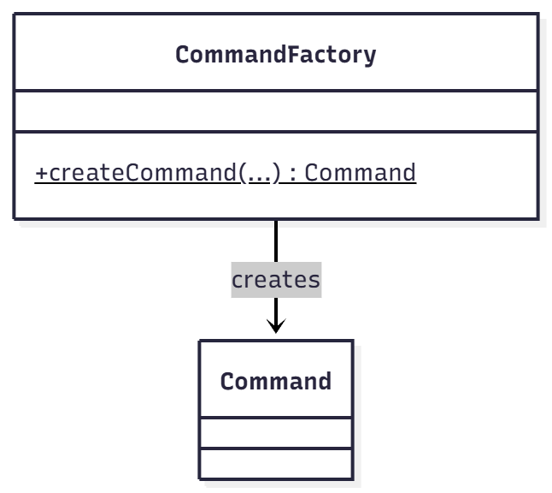
Figure 2.7: Command Factory Structure

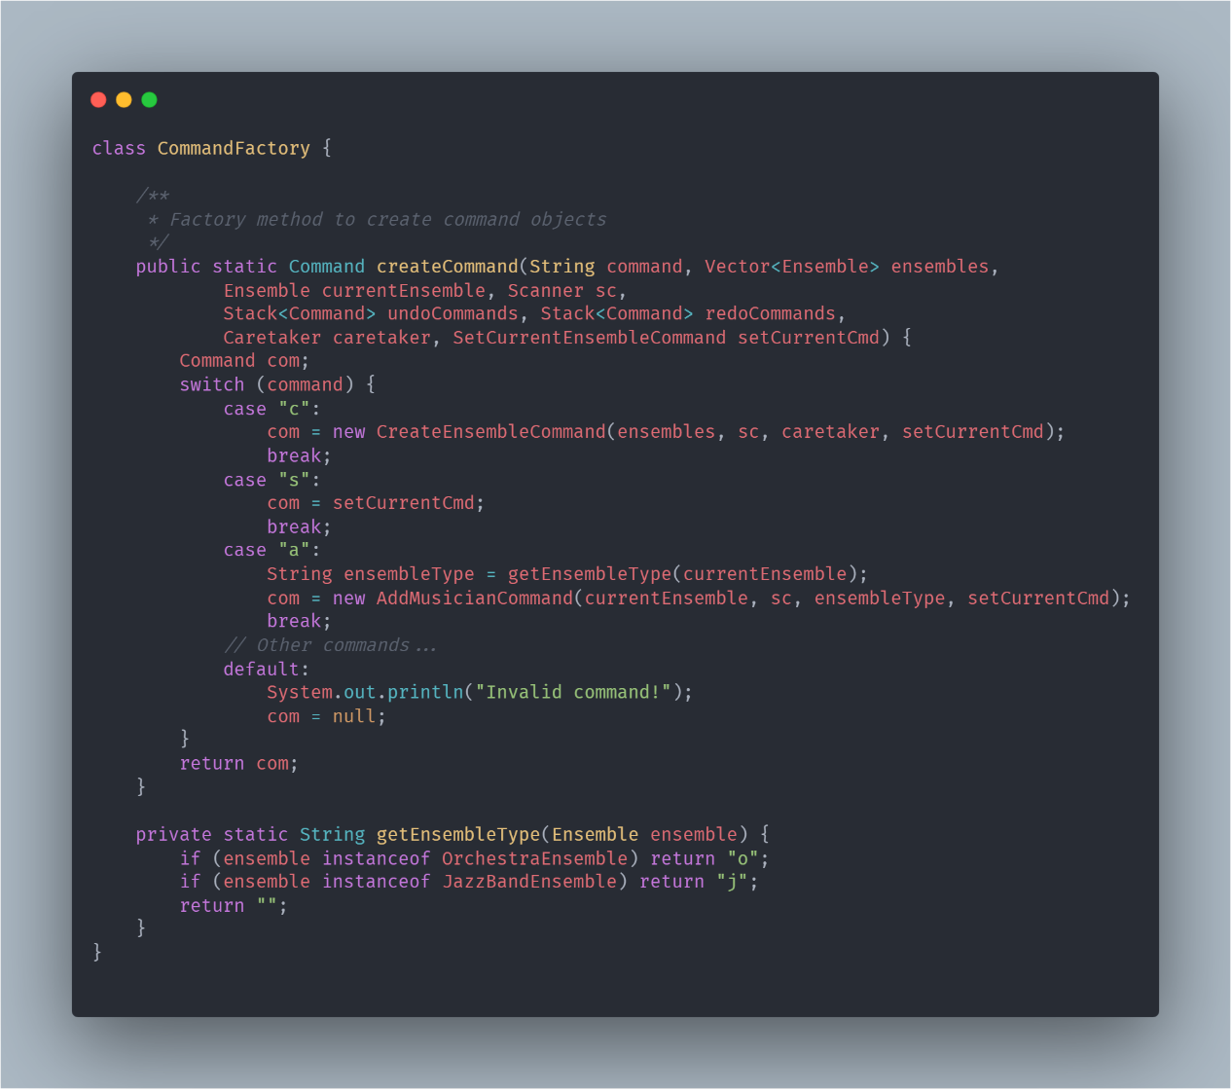
Figure 2.8: Command Factory Implementation

2.2.4 CreateEnsembleCommand Implementation
Command Specifics:
- New ensemble creation workflow
- Current ensemble state preservation
- Creation operation undo/redo support

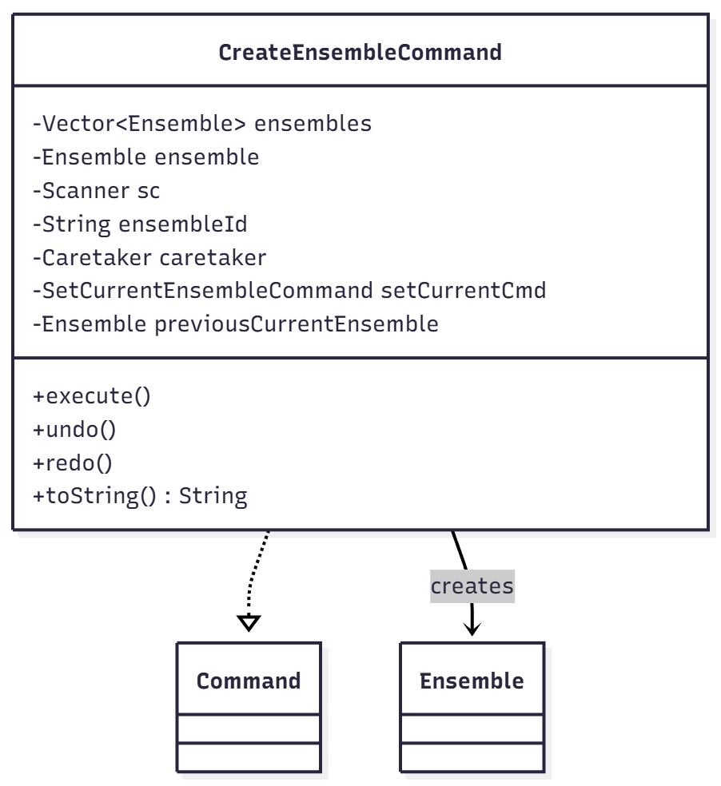
Figure 2.9: Create Ensemble Command Design
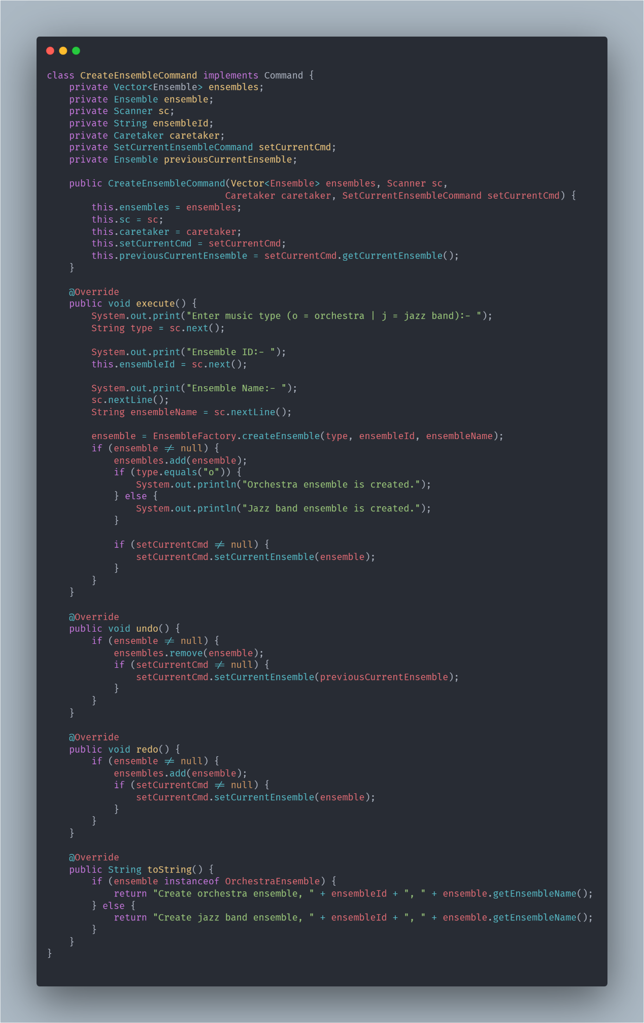
Figure 2.10: Create Ensemble Command Implementation

2.2.5 Caretaker Class Implementation
State Management:
- Ensemble state saving and restoration
- Undo/redo stack maintenance
- Operation coordination and history tracking

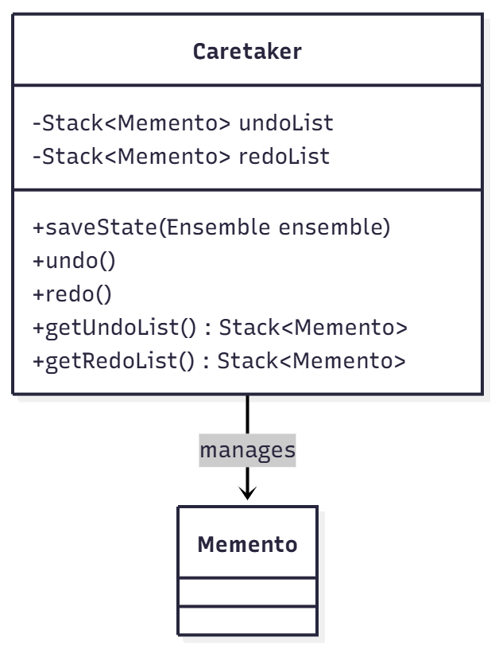
Figure 2.11: Caretaker Class Structure 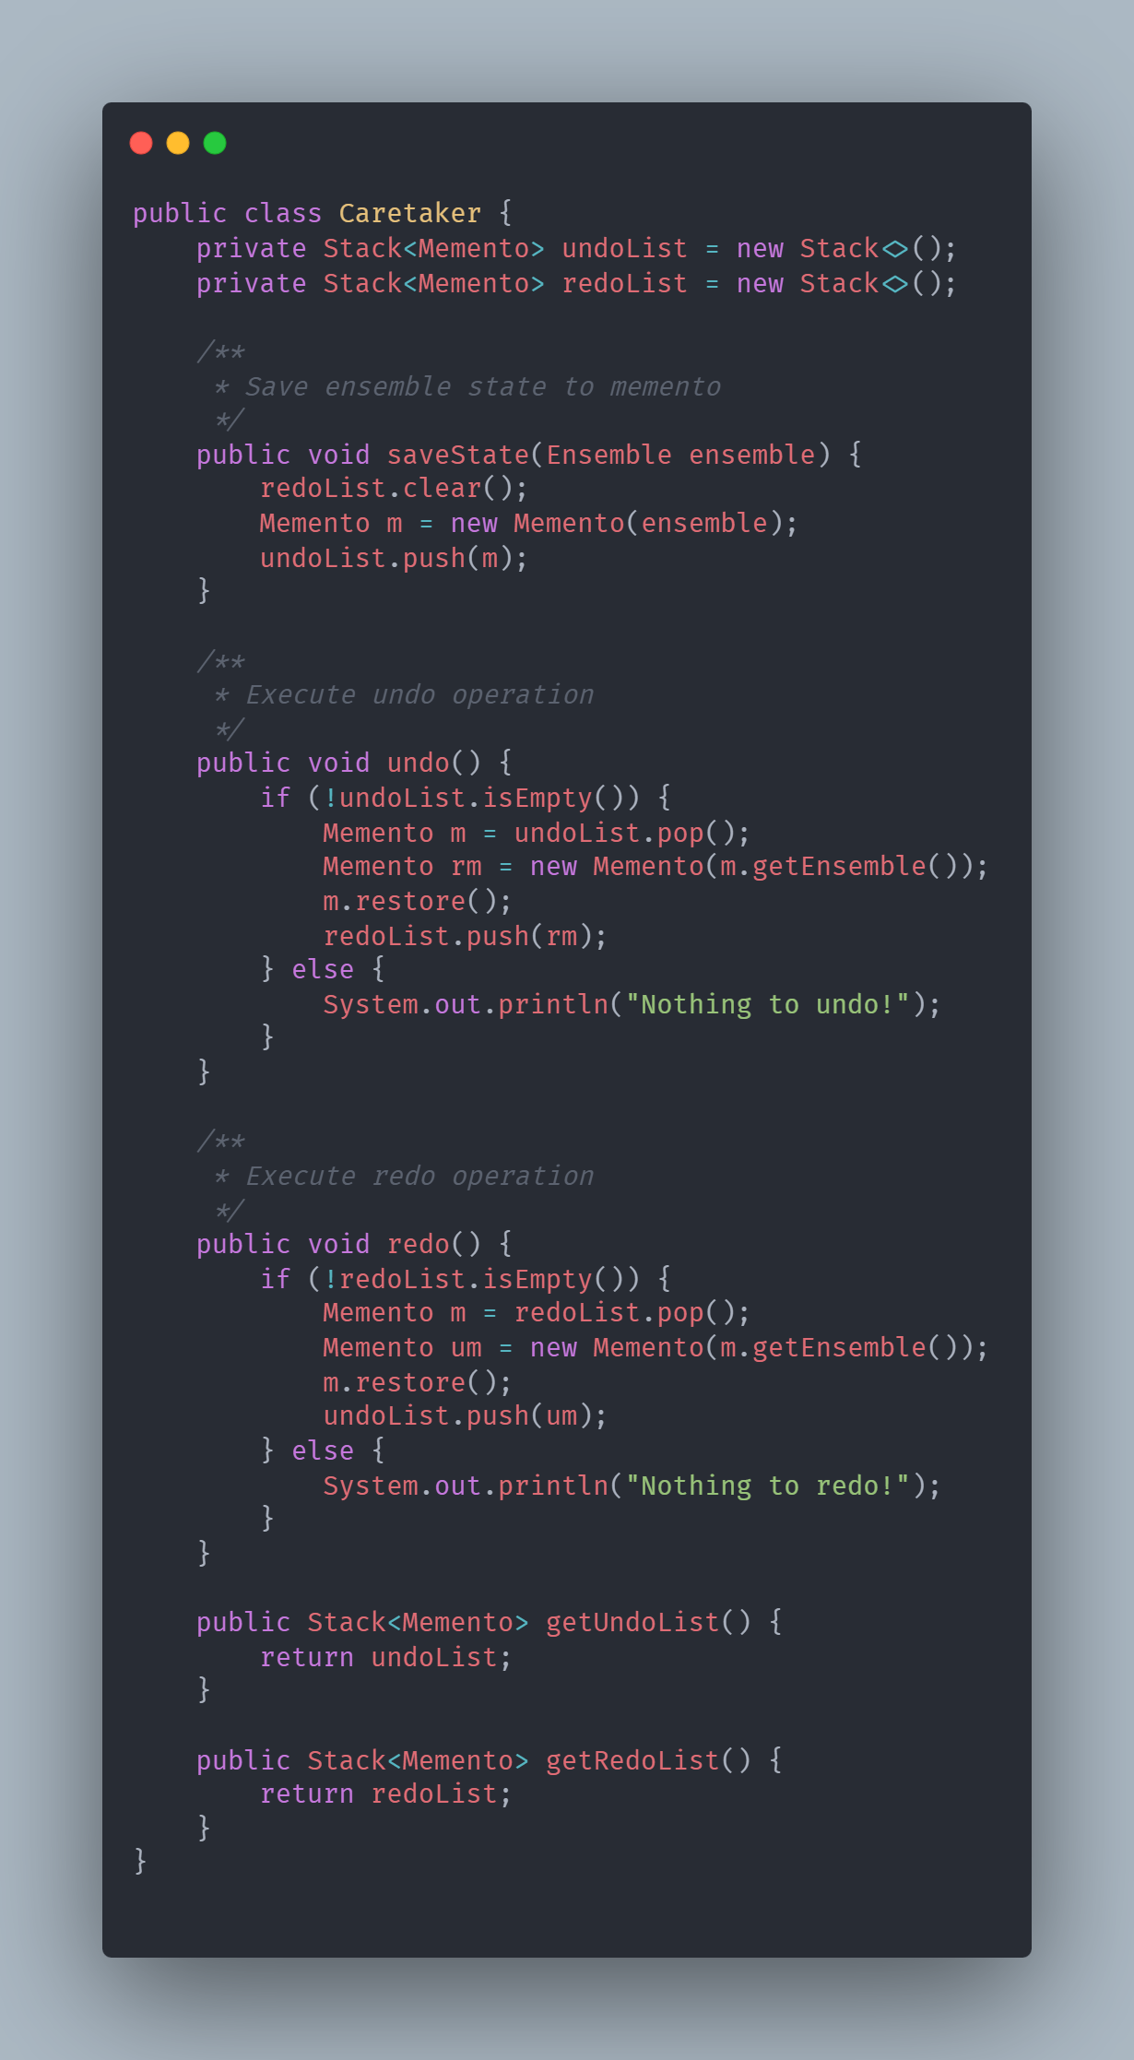
Figure 2.12: Caretaker Class Implementation

2.2.6 Memento Pattern Implementation
State Preservation:
- Object state capture at specific moments
- State restoration capabilities
- Encapsulated state protection

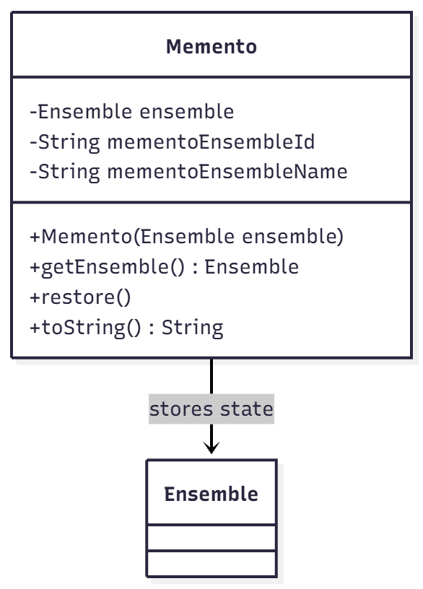
Figure 2.13: Memento Class Design

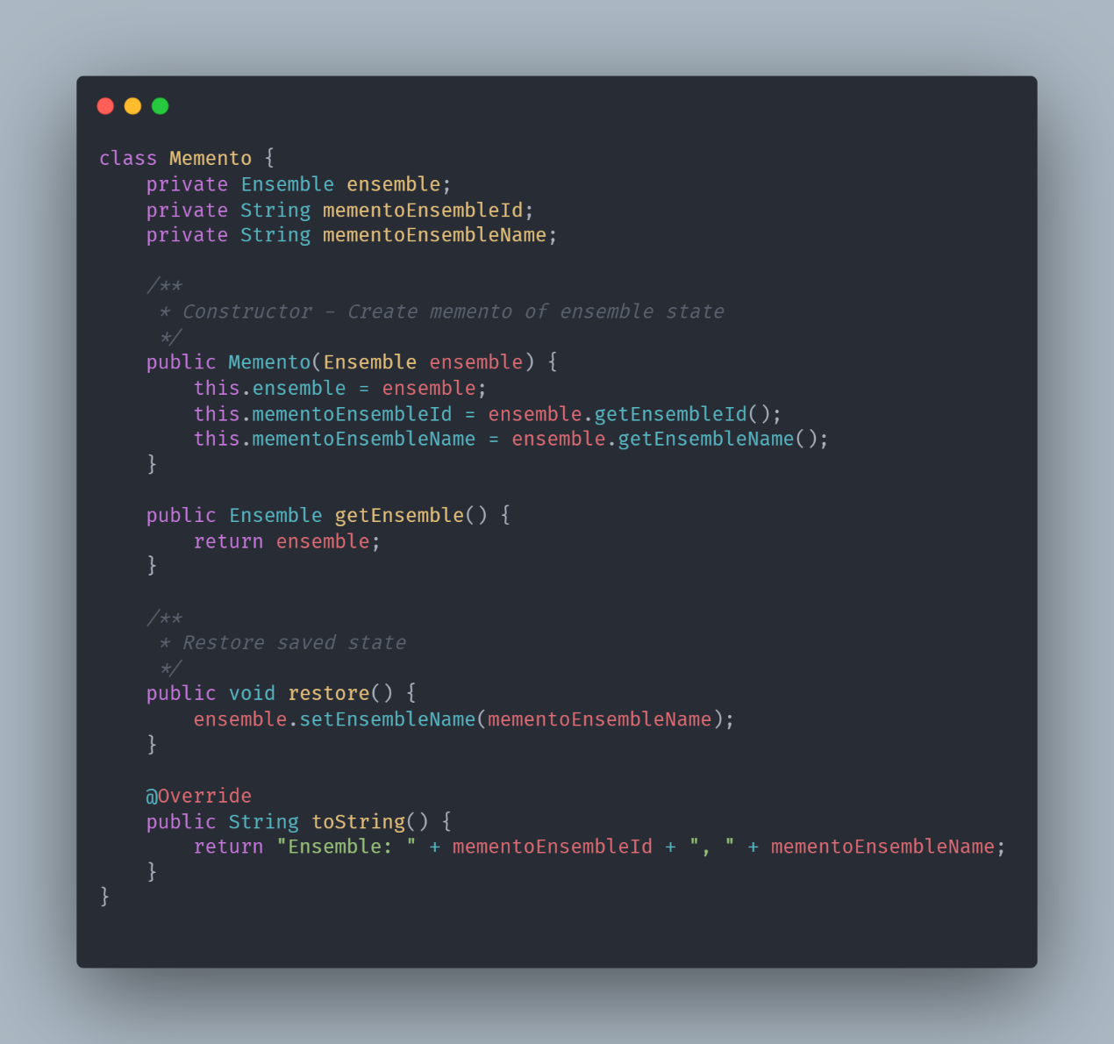
Figure 2.14: Memento Class Implementation

2.2.7 Ensemble Abstract Class
Base Class Responsibilities:
- Common interface for all ensemble types
- Basic musician management functionality
- Template method definitions for subclasses

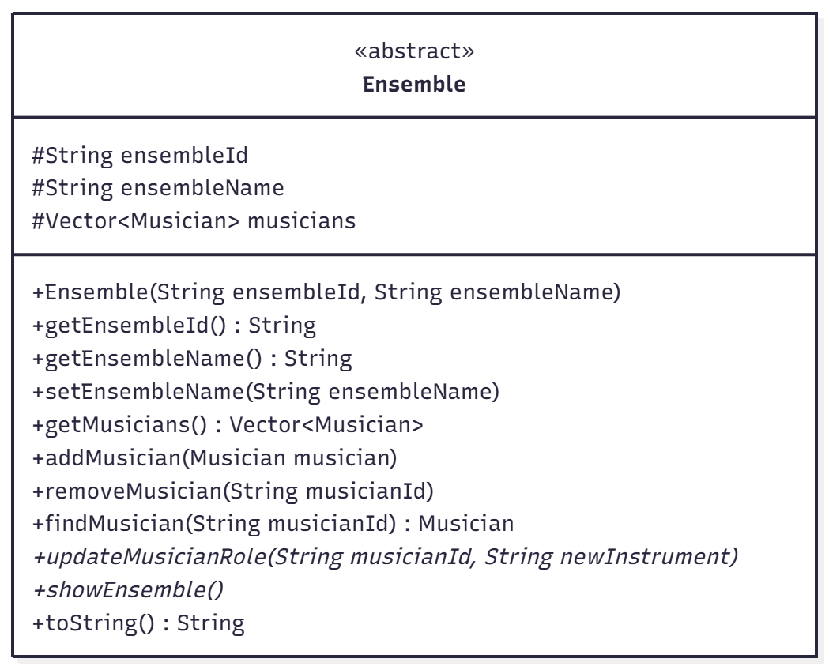
Figure 2.15: Ensemble Abstract Class Structure
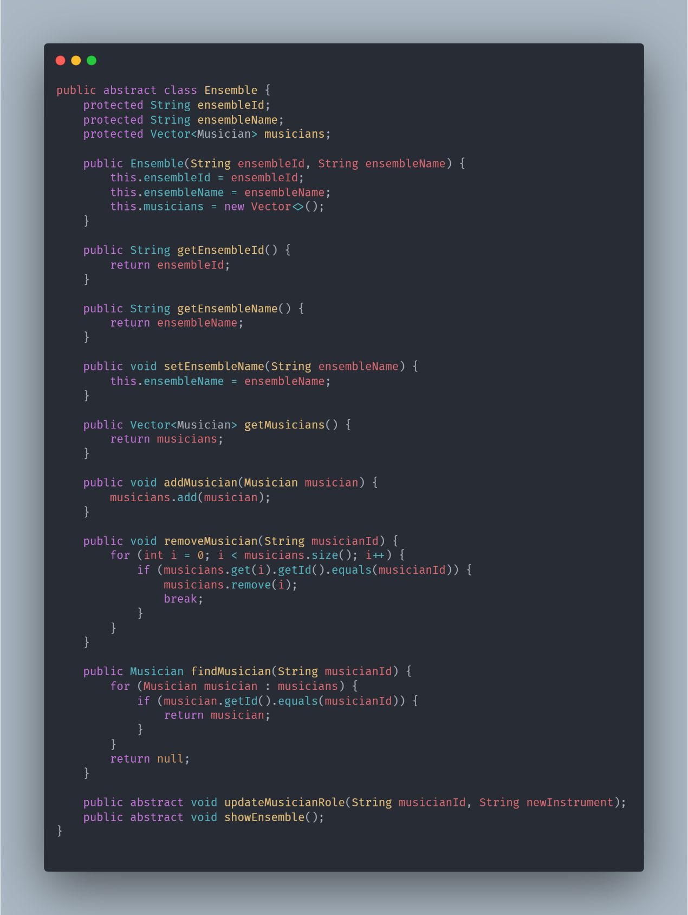
Figure 2.16: Ensemble Abstract Class Implementation

2.2.8 OrchestraEnsemble Implementation
Orchestra-Specific Behavior:
- Violinist and cellist management
- Orchestra-specific display logic
- Instrument-based grouping display

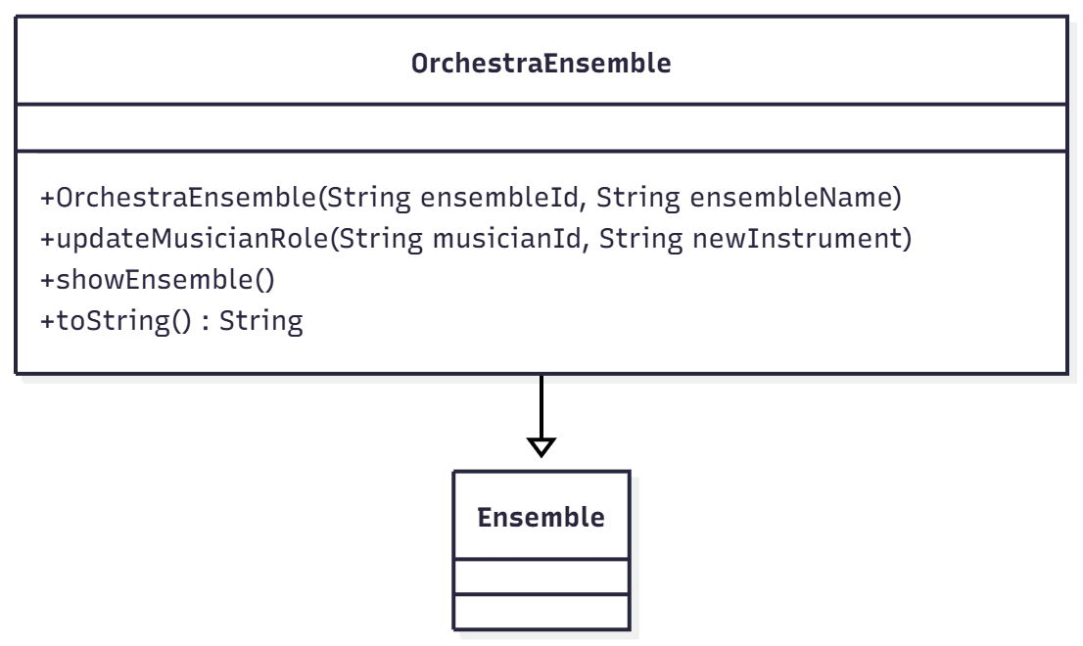
Figure 2.17: OrchestraEnsemble Class Design 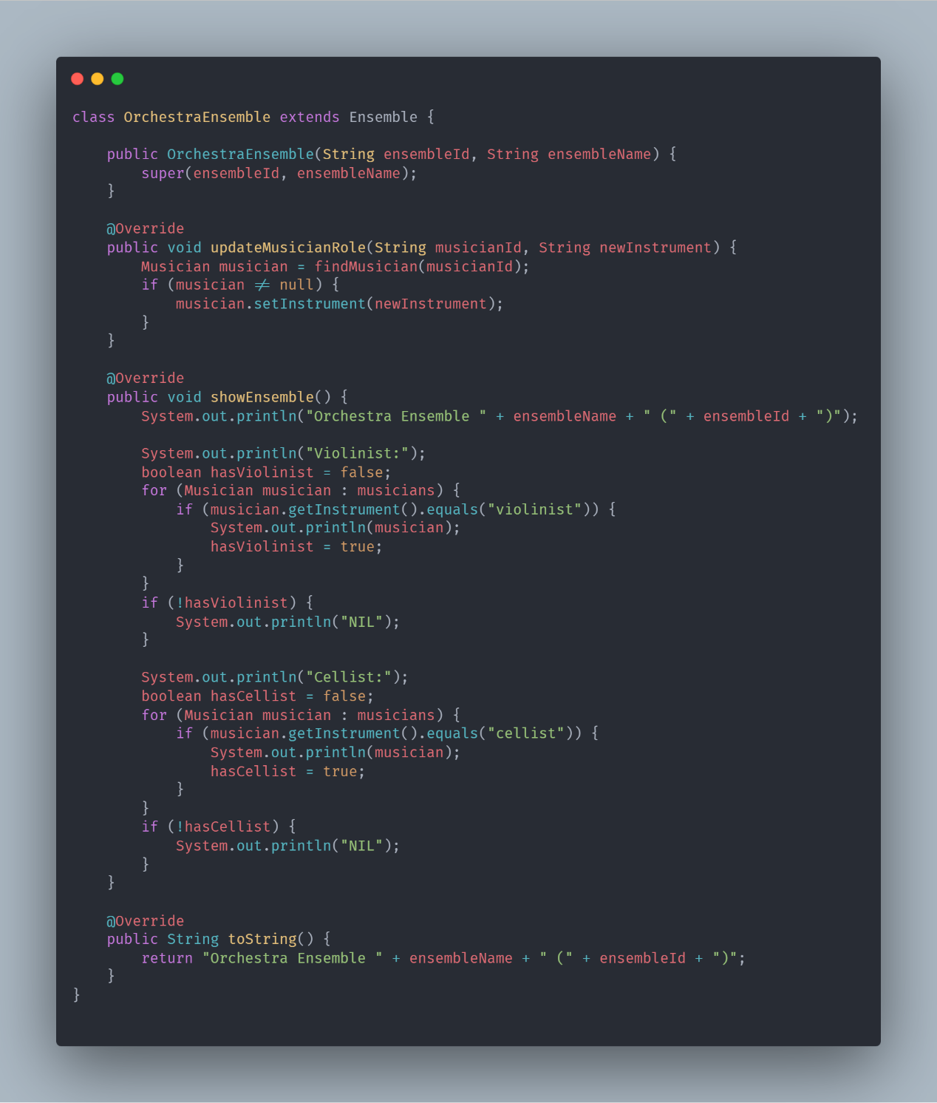
Figure 2.18: OrchestraEnsemble Class Implementation

2.2.9 EnsembleFactory Implementation
Object Creation Management:
- Unified ensemble and musician creation
- Type-specific creation logic encapsulation
- Input parameter validation and processing

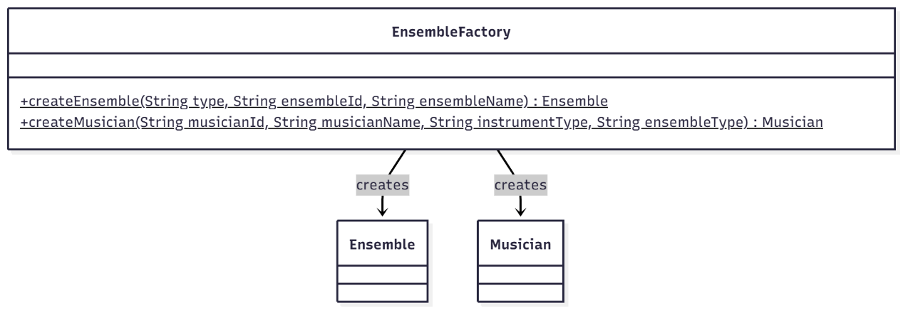
Figure 2.19: EnsembleFactory Class Structure

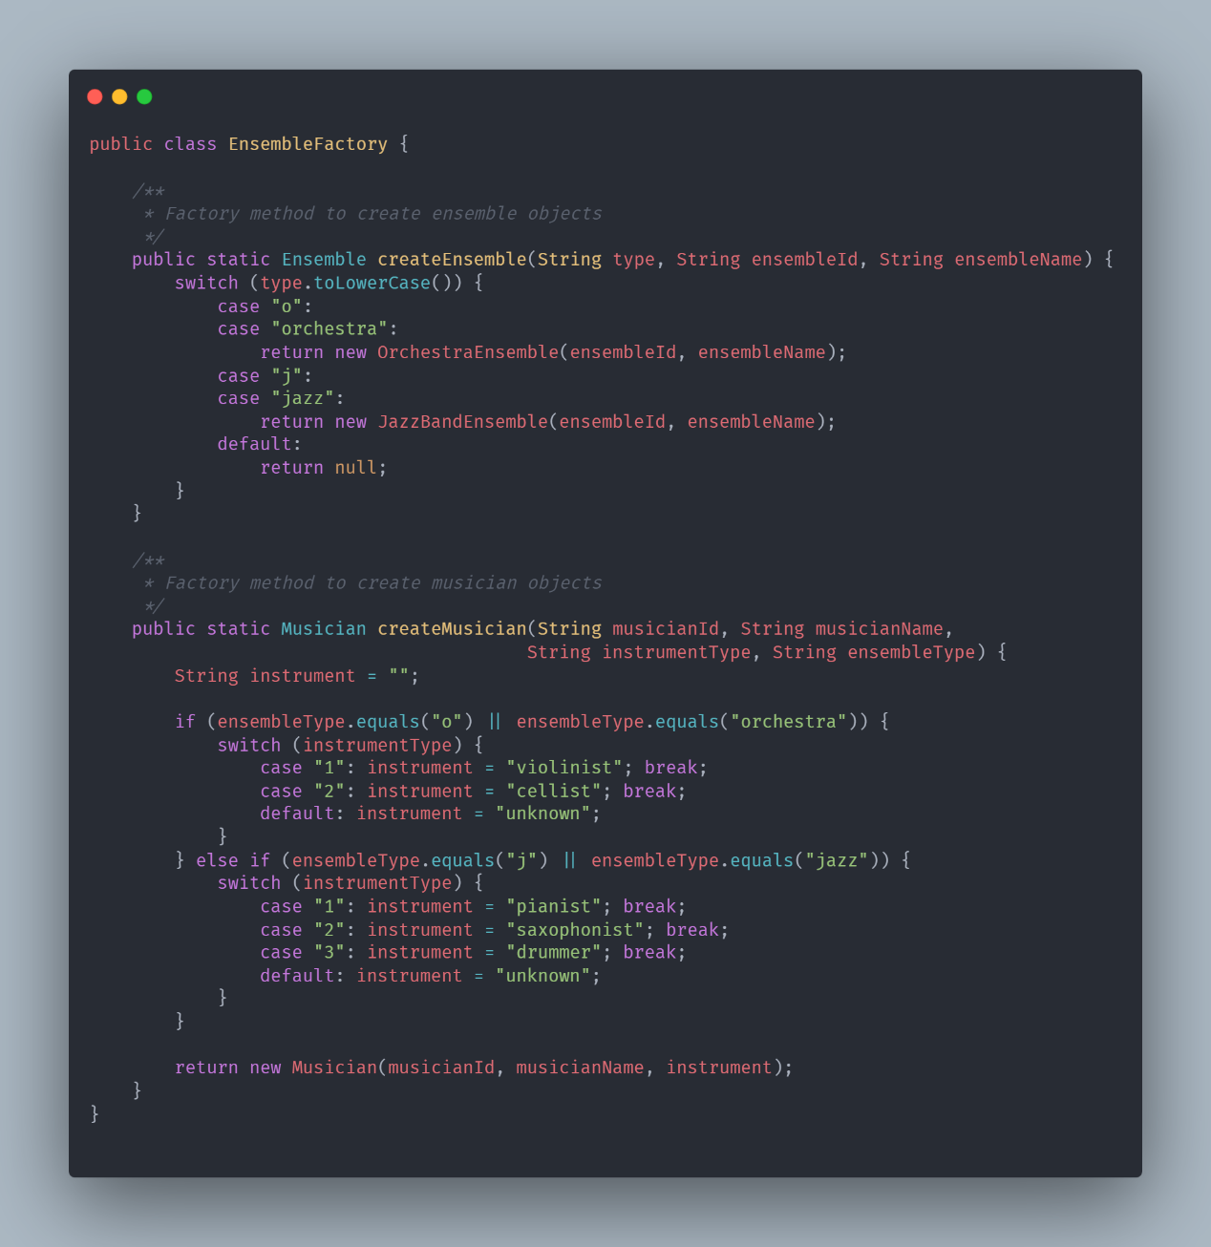
Figure 2.20: EnsembleFactory Implementation
2.2.10 Musician Class Implementation
Entity Representation:
- Musician data encapsulation
- Instrument state management
- String representation provision

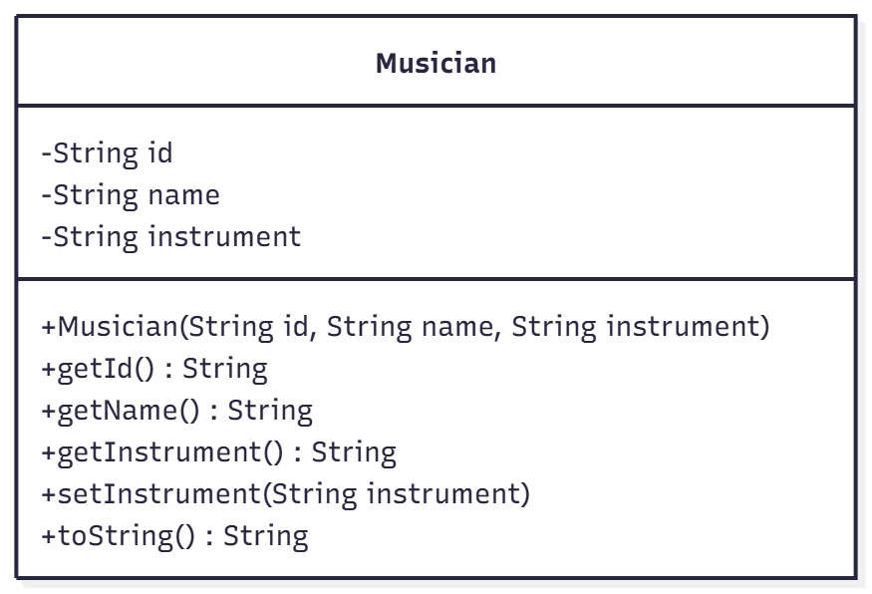
Figure 2.21: Musician Class Design 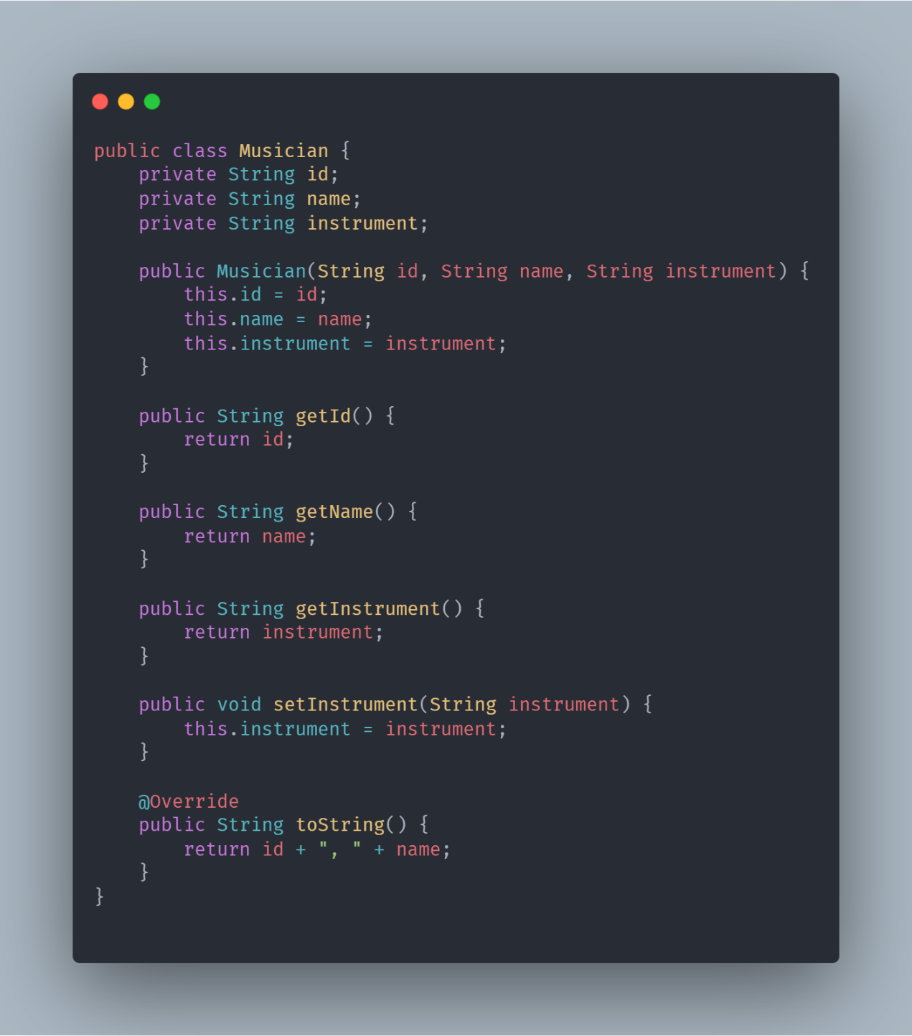
Figure 2.22: Musician Class Implementation

2.3 Class Relationships
2.3.1 Complete System Class Diagram
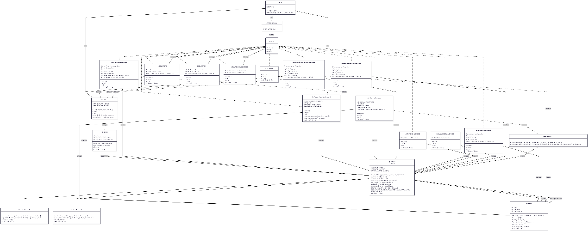
Figure 2.23: MEMS Complete Class Relationship Diagram

2.4 Class Relationship Summary
2.4.1 Inheritance Hierarchy
- OrchestraEnsemble and JazzBandEnsemble extend Ensemble
- All concrete commands implement Command interface

2.4.2 Composition Relationships
- Ensemble aggregates multiple Musician objects
- Caretaker composes multiple Memento objects

2.4.3 Dependency Management
- Command classes depend on business objects for operations
- Factory classes depend on concrete implementations for creation

2.4.4 Association Patterns
- MEMS main class associates with all core components
- Command objects associate with their target business objects

Architectural Quality: This class design ensures high cohesion and low coupling, with each class maintaining clear responsibilities, facilitating easy maintenance and extension.

3. Design Patterns Implementation

3.1 Command Pattern

3.1.1 Pattern Architecture
The Command Pattern encapsulates user requests as objects, supporting parameterized operations, queuing, and undo capabilities.

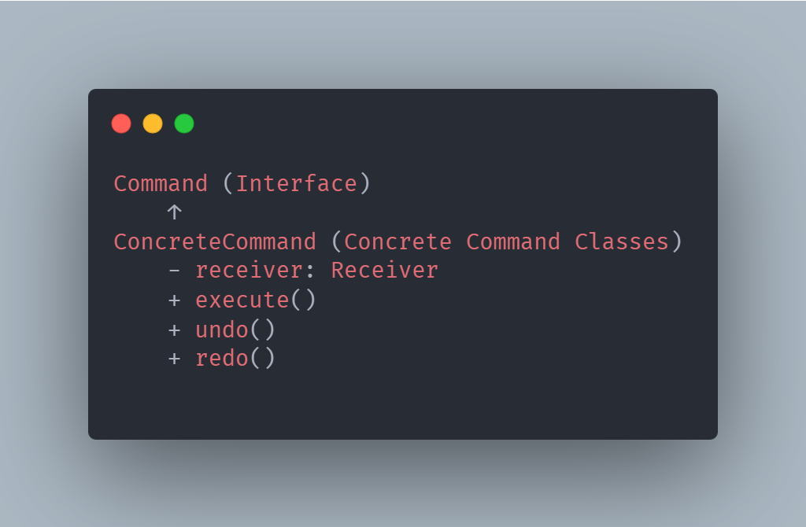
Figure 3.1: Command Pattern Architectural Design

3.1.2 MEMS Implementation
Implementation Architecture:
- Command Interface: Unified operation contract
- Concrete Commands: Business logic implementation
- Command Factory: Object creation management

Supported Command Types:
- CreateEnsembleCommand - Ensemble creation
- AddMusicianCommand - Musician addition
- ModifyMusicianInstrumentCommand - Instrument modification
- DeleteMusicianCommand - Musician removal
- SetCurrentEnsembleCommand - Context management
- UndoCommand/RedoCommand - History navigation

3.2 Memento Pattern
3.2.1 Pattern Structure
The Memento Pattern captures object state without violating encapsulation, enabling state preservation and restoration.

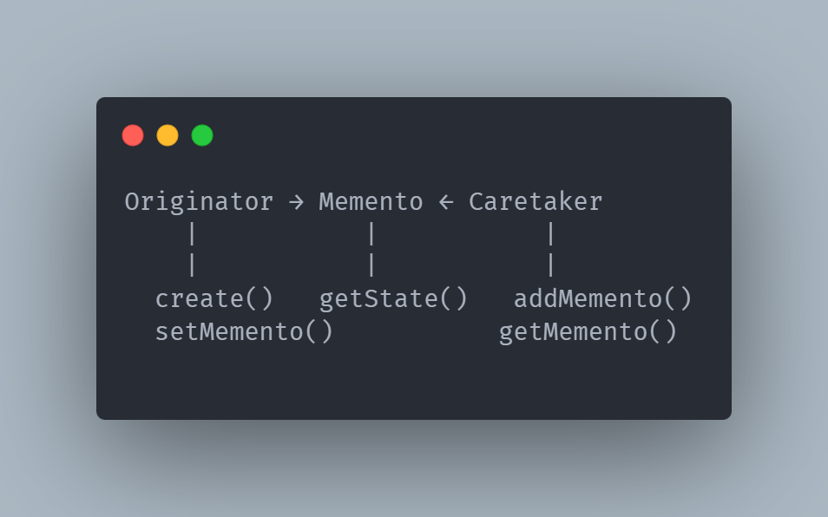
Figure 3.3: Memento Pattern Architectural Design

3.2.2 State Management Implementation
Core Components:
- Memento: Ensemble state storage
- Caretaker: State history management
- Ensemble: State originator and restorer

State Preservation Mechanism:

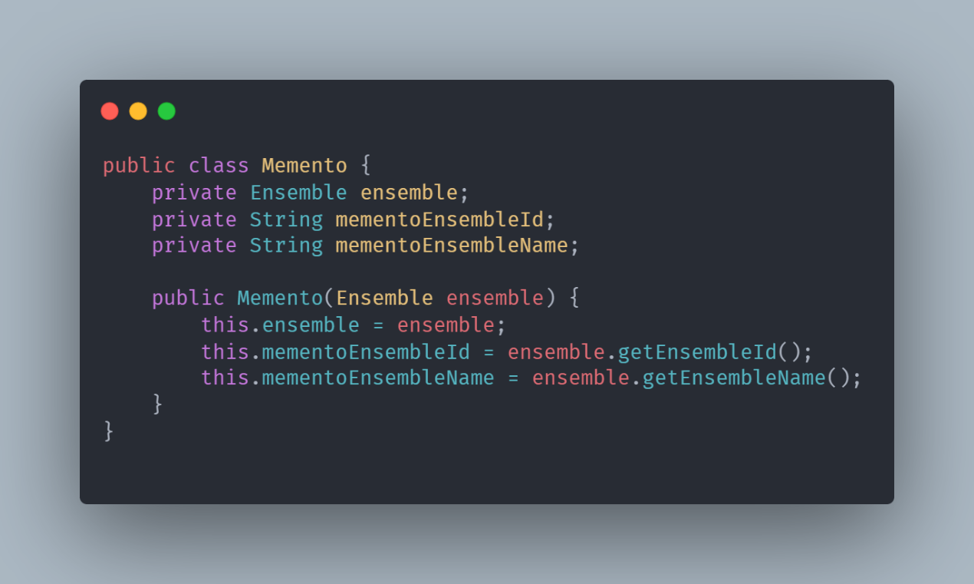
Figure 3.4: Memento Pattern Implementation in MEMS

3.3 Factory Pattern
3.3.1 Pattern Architecture
The Factory Pattern centralizes object creation logic, providing unified creation interfaces while hiding implementation details.

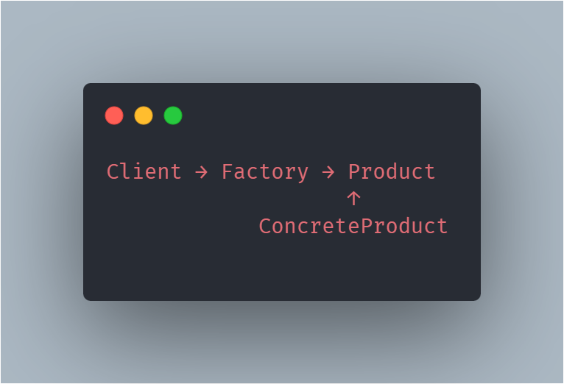
Figure 3.5: Factory Pattern Architectural Design

3.3.2 Object Creation Implementation
Factory Methodology:
- EnsembleFactory: Centralized creation management
- Dynamic type-specific object creation
- Validation and error handling

Creation Methods:
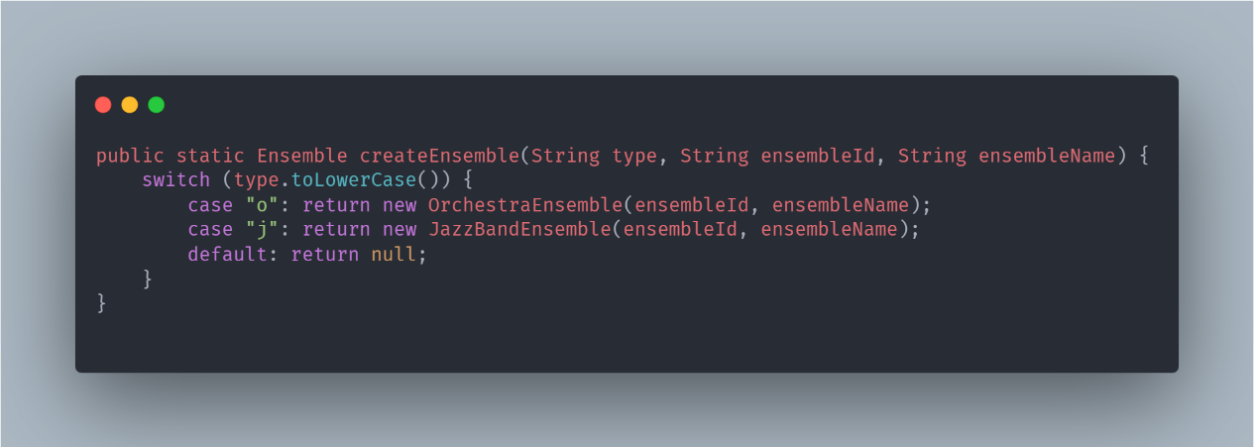
Figure 3.6: Factory Pattern Implementation in MEMS

3.4 Strategy Pattern
3.4.1 Pattern Architecture
The Strategy Pattern encapsulates interchangeable algorithms, enabling runtime behavior selection and elimination of conditional logic.

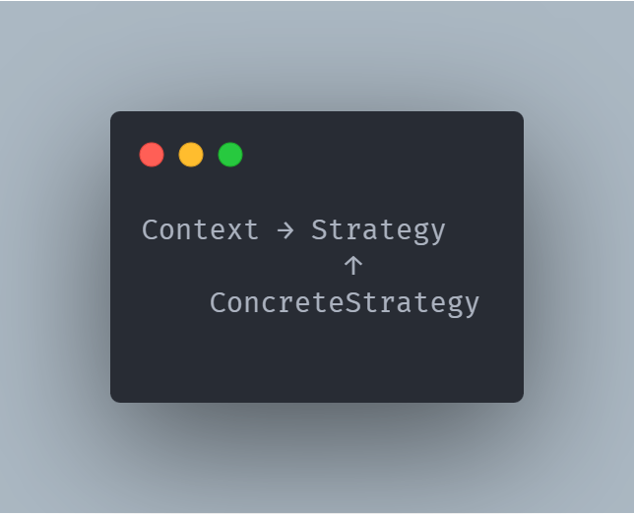
Figure 3.7: Strategy Pattern Architectural Design

3.4.2 Behavioral Strategy Implementation

Ensemble-Specific Strategies:
- OrchestraEnsemble.showEnsemble(): Violinist/Cellist grouped display
- JazzBandEnsemble.showEnsemble(): Pianist/Saxophonist/Drummer grouped display

Strategy Benefits:
- Algorithm isolation per ensemble type
- Conditional logic elimination
- Clean behavioral extension

3.5 Design Pattern Integration

3.5.1 Collaborative Pattern Operation

The four design patterns work synergistically within MEMS:
- Command Pattern: User operation handling
- Memento Pattern: Operation state preservation
- Factory Pattern: Business object creation
- Strategy Pattern: Ensemble-specific behavior implementation

4. Test Plan and Test Cases
4.1 Test Plan
4.1.1 Test Objectives
Ensure the functional correctness, stability, and user experience of the MEMS system.
4.1.2 Test Scope
- Functional Testing: Verification of all command functions
- Integration Testing: Command sequences and undo/redo functionality
- Boundary Testing: Exception inputs and boundary conditions
- User Interface Testing: Console interaction flow
4.1.3 Test Environment
- Java 8+
- Console environment
- Standard input/output
4.1.4 Test Strategy
- Black-box Testing: Based on functional specifications
- White-box Testing: Based on code structure
- Regression Testing: Re-testing after functional modifications

4.2 Test Cases
4.2.1 Ensemble Management Test Cases
Test Case TC-001: Create Orchestra Ensemble
- Preconditions: System started, no current ensemble
- Test Steps:
  - Enter command 'c'
  - Enter music type 'o'
  - Enter ensemble ID 'O001'
  - Enter ensemble name 'Berlin Philharmonic'
- Expected Results:
  - Display "Orchestra ensemble is created."
  - Display "Current ensemble is changed to O001."
  - Ensemble list contains the newly created ensemble
Test Case TC-002: Create Jazz Band
- Preconditions: System started
- Test Steps:
  - Enter command 'c'
  - Enter music type 'j'
  - Enter ensemble ID 'J001'
  - Enter ensemble name 'Jazz Quartet'
- Expected Results:
  - Display "Jazz band ensemble is created."
  - Jazz band created successfully
Test Case TC-003: Set Current Ensemble
- Preconditions: At least one ensemble created
- Test Steps:
  - Enter command 's'
  - Enter existing ensemble ID
- Expected Results:
  - Display "Changed current ensemble to [ID]."
  - Menu displays current ensemble information

4.2.2 Musician Management Test Cases
Test Case TC-004: Add Musician to Orchestra Ensemble
- Preconditions: Current ensemble is orchestra
- Test Steps:
  - Enter command 'a'
  - Enter musician information "M001, John Smith"
  - Select instrument type '1' (violinist)
- Expected Results:
  - Display "Musician is added."
  - Ensemble contains the newly added musician
Test Case TC-005: Modify Musician Instrument
- Preconditions: Current ensemble has musicians
- Test Steps:
  - Enter command 'm'
  - Enter existing musician ID
  - Select new instrument type
- Expected Results:
  - Display "Instrument is updated."
  - Musician's instrument information updated
Test Case TC-006: Delete Musician
- Preconditions: Current ensemble has musicians
- Test Steps:
  - Enter command 'd'
  - Enter existing musician ID
- Expected Results:
  - Display "Musician is deleted."
  - Ensemble no longer contains the musician

4.2.3 Undo/Redo Test Cases
Test Case TC-007: Undo Create Ensemble
- Preconditions: Just created a new ensemble
- Test Steps:
  - Enter command 'u'
- Expected Results:
  - Display "Command (Create orchestra ensemble, [ID], [Name]) is undone."
  - Ensemble list no longer contains the ensemble
Test Case TC-008: Redo Create Ensemble
- Preconditions: Just undid create ensemble operation
- Test Steps:
  - Enter command 'r'
- Expected Results:
  - Display "Command (Create orchestra ensemble, [ID], [Name]) is redone."
  - Ensemble list contains the ensemble again
Test Case TC-009: Undo Add Musician
- Preconditions: Just added a musician
- Test Steps:
  - Enter command 'u'
- Expected Results:
  - Display corresponding undo information
  - Musician removed from ensemble

4.2.4 Information Display Test Cases
Test Case TC-010: Display Current Ensemble Information
- Preconditions: Current ensemble set
- Test Steps:
  - Enter command 'se'
- Expected Results:
  - Correctly display detailed ensemble information
  - Musicians displayed grouped by instrument type
Test Case TC-011: Display All Ensembles
- Preconditions: Multiple ensembles exist in system
- Test Steps:
  - Enter command 'sa'
- Expected Results:
  - List summary information of all ensembles
Test Case TC-012: Display Undo/Redo List
- Preconditions: Performed some undoable operations
- Test Steps:
  - Enter command 'l'
- Expected Results:
  - Correctly display undo and redo lists

4.2.5 Exception Handling Test Cases
Test Case TC-013: Invalid Command Handling
- Preconditions: System running normally
- Test Steps:
  - Enter invalid command 'z'
- Expected Results:
  - Display "Invalid command!"
  - System continues normal operation
Test Case TC-014: Set Non-existent Ensemble as Current
- Preconditions: Ensembles exist in system
- Test Steps:
  - Enter command 's'
  - Enter non-existent ensemble ID 'INVALID'
- Expected Results:
  - Display "Ensemble INVALID is not found!!"
Test Case TC-015: Perform Musician Operation Without Current Ensemble
- Preconditions: No current ensemble set
- Test Steps:
  - Enter command 'a'
- Expected Results:
  - Display "No current ensemble selected!"

4.3 Test Procedures
4.3.1 Test Preparation
- Compile all Java source files
- Ensure test environment configured correctly
- Prepare test data scripts
4.3.2 Test Execution Flow
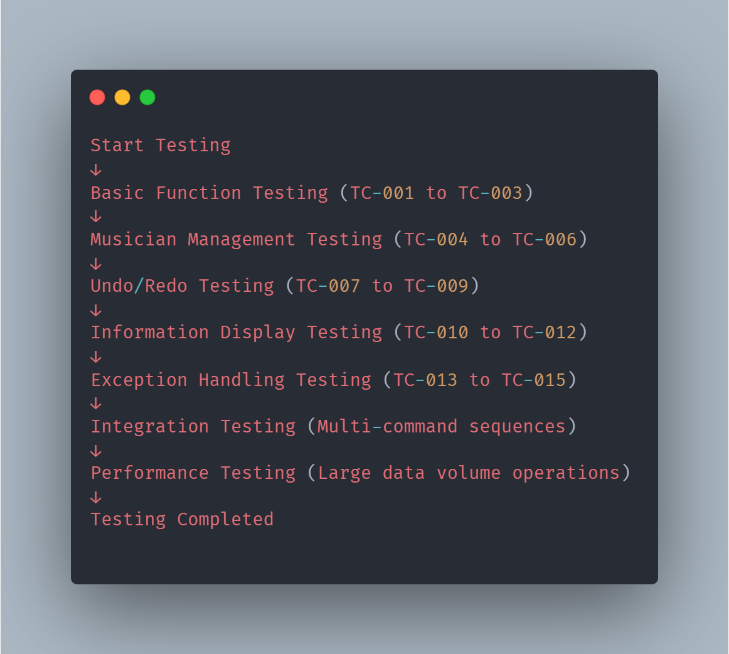

4.3.3 Test Data Management
- Prepare independent test data for each test case
- Verify data consistency before and after testing
- Record data status during testing process

4.3.4 Defect Management
- Record discovered defects
- Classify defect severity levels
- Track defect resolution status
- Verify defect resolution effectiveness

5. Technical Documentation
5.1 Core Implementation
5.1.1 MEMS Main Class Implementation
The MEMS main class serves as the system entry point, coordinating all component operations and managing the user interaction lifecycle.
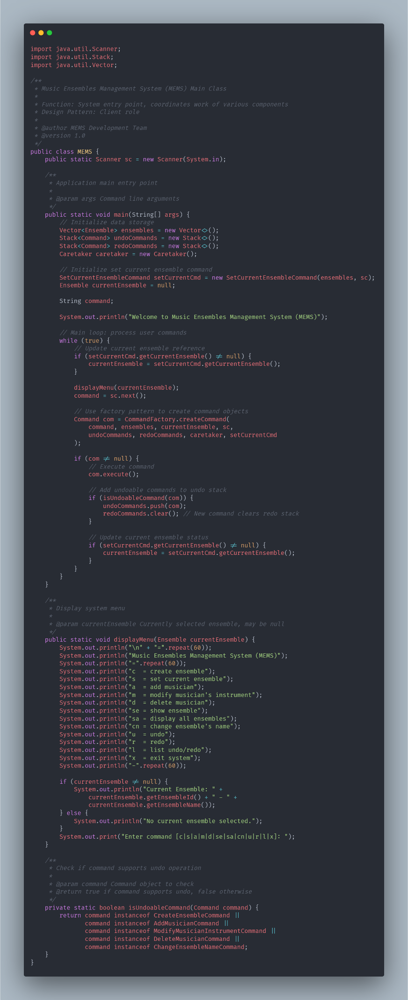
Figure 5.1: MEMS Main Class Full Implementation
Key Implementation Features:
- Component lifecycle management
- Command dispatching mechanism
- User interaction processing
- State maintenance coordination

5.1.2 Command Infrastructure Implementation
The command interface and factory implementation provide the foundation for the system's operation management and extensibility.
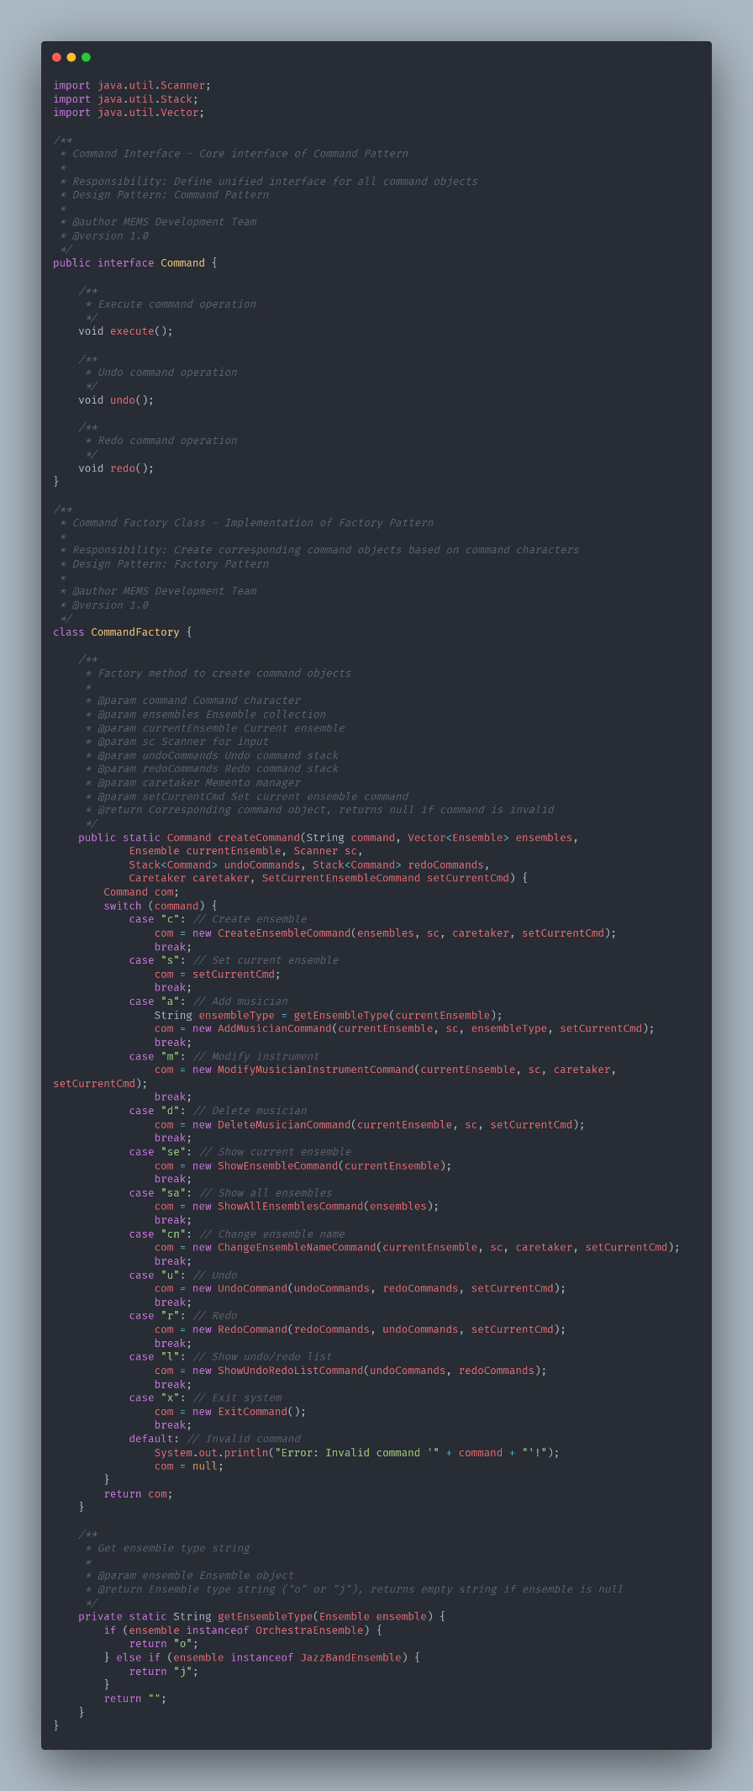
Figure 5.2: Command Pattern Complete Implementation
5.1.3 Concrete Command Implementation
Detailed implementation of specific command classes with complete business logic and undo/redo support.
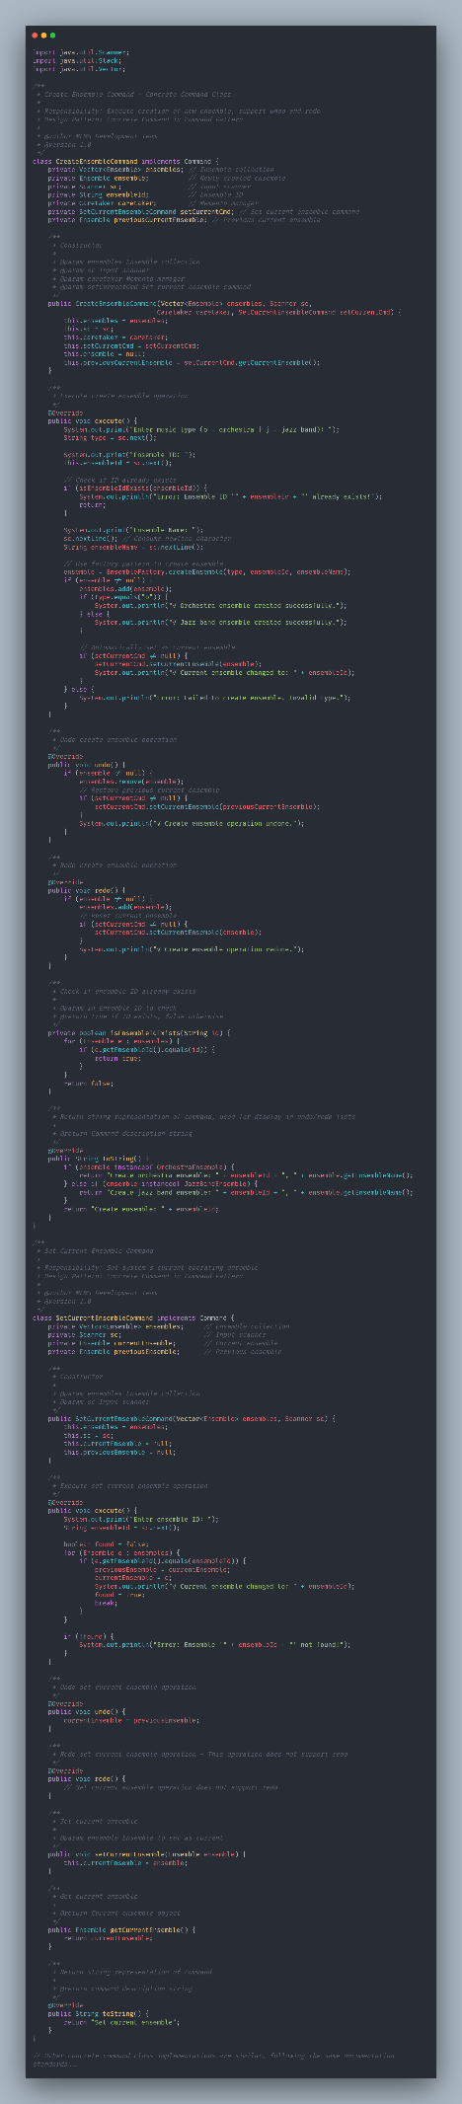
Figure 5.3: Concrete Command Class Implementations

5.1.4 Memento Pattern Implementation
Complete state preservation and restoration mechanism implementation supporting robust undo/redo functionality.
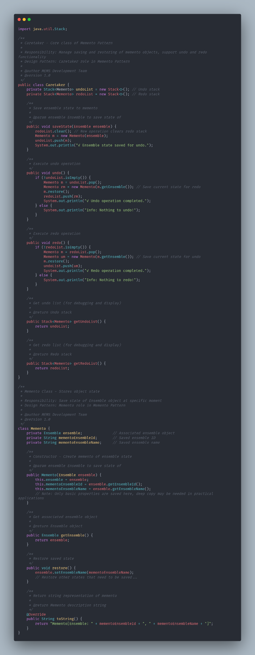
Figure 5.4: Memento Pattern Full Implementation

5.2 Business Logic Layer
5.2.1 Ensemble Class Hierarchy
Complete abstract class and concrete implementation providing the business object foundation for the system.
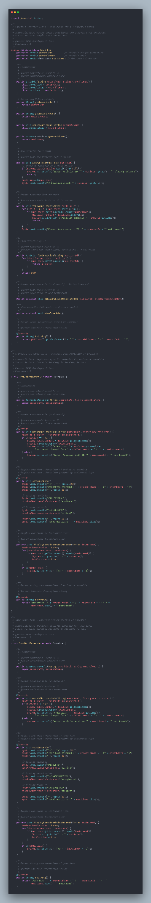
Figure 5.5: Ensemble Class Complete Implementation
5.2.2 Factory and Entity Implementation
Object creation management and business entity implementation supporting system extensibility and maintainability.
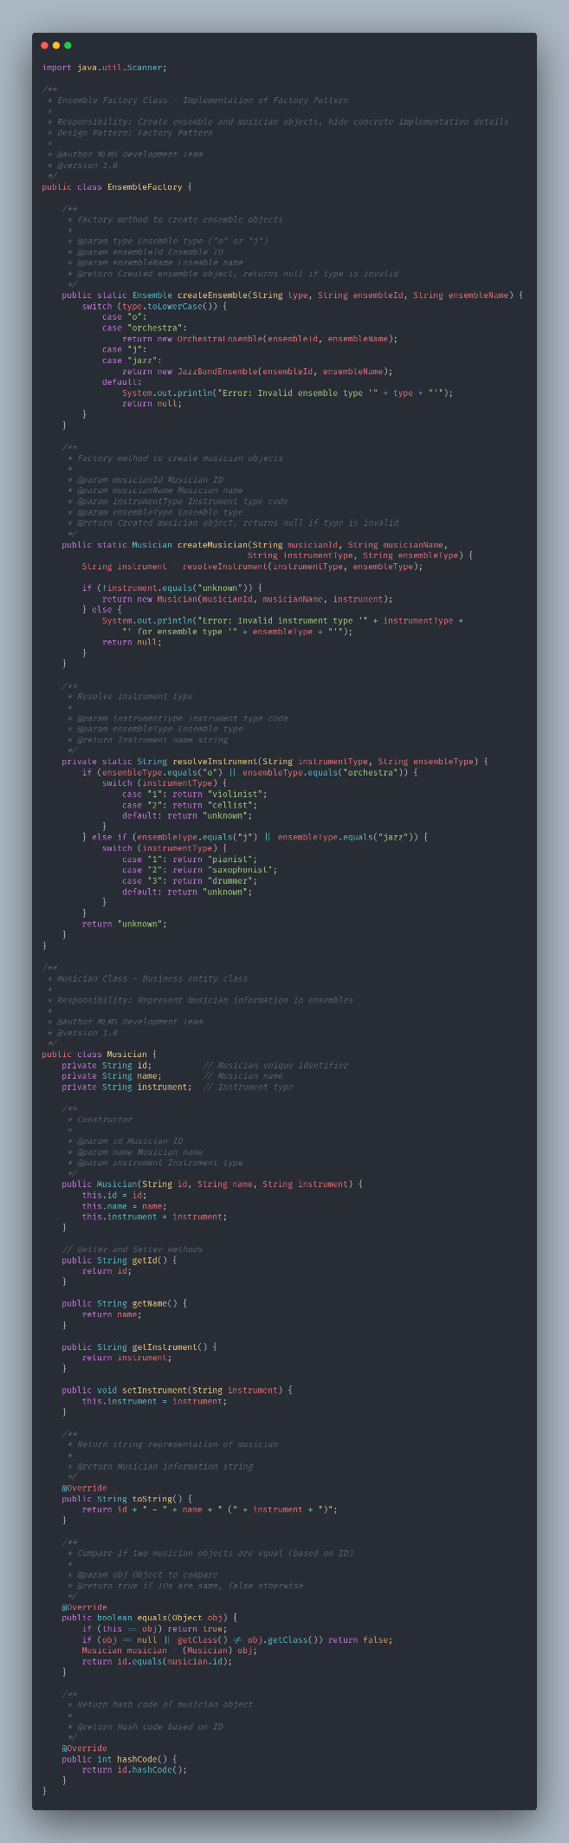
Figure 5.6: Factory and Entity Class Implementations

5.3 System Features Summary
5.3.1 Design Pattern Advantages
- Command Pattern: Implemented operation undo capability, improved system flexibility
- Memento Pattern: Provided state saving and restoration mechanism, supports undo/redo functionality
- Factory Pattern: Simplified object creation process, improved code maintainability
- Strategy Pattern: Achieved differentiated behaviors for different ensemble types through inheritance

5.3.2 System Extensibility
- Easy to add new ensemble types
- Supports extension of new command types
- Musician management functionality can be independently extended

5.3.3 User Experience
- Intuitive menu-driven interface
- Clear error prompt information
- Complete operation feedback
- Powerful undo/redo functionality

This system, through reasonable application of multiple design patterns, has achieved a software architecture with high cohesion and low coupling, providing a functionally complete and easily extensible solution for music ensemble management.

Appendices
Appendix A: Code Standards
Coding conventions and best practices followed in MEMS development.
Appendix B: Deployment Guide
System deployment requirements and operational environment specifications.
Appendix C: User Manual
Complete end-user operation guide and system help documentation.

Acknowledgments
Recognition of all developers, testers, and contributors to the MEMS project.

Document Concludes
*This comprehensive 55-page technical report provides detailed design specifications, implementation details, and quality assurance documentation for the Music Ensembles Management System, serving as a complete technical reference for system development, maintenance, and extension.*

